Club ItaloAmericano of Green Bay

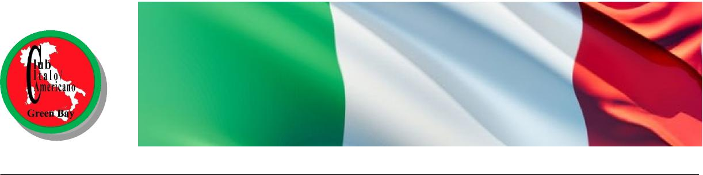
Founded 1994
2018 Membership Renewal
Your annual membership renewal is $20.00 per person. Renewals are due on or before January 31, 2018. Pay by the due date and enjoy a $5.00 discount ($15.00 per person).
Name (please print)
Name (please print)
Street/POBox____________________________________City_________ Zip
Home Phone ____________________________Cell #1__________________________
Cell #2
Email_______________________________________ (Club communications only)
Make check payable to: Club ItaloAmericano or CIAGB
Mail to our Club Treasurer: Victoria (Piccione) Sobeck, 1810 Oakhill Drive, Green Bay, WI 54313-4800
Your Club is here to provide a venue for you to get together with other people who, like you, have an interest in the Italian culture. It is a member driven organization and only continues to function because its members participate by adding their spirit and viewpoint to the Club. Why not try it, you might like it. Besides, we do have tons of fun (It’s required!) while working on the Club’s projects.
Grab your pencil and indicate which committee / project you would like to work on:
Carnevale _____ Spaghetti Dinner ____ Musicale _____ Cena di Natale _____ Dinner & an Italian Movie _____ Passeggiata _____ Cooking Demonstrations _____ Work w/High School Italian language students______
Membership_____ Publicity_____ Marketing_____ Other ________________________________________________
Suggestions/Comments___________________________________________________________________________
Suggestions / comments__________________________________________________________________________

